Ch5-Working with Providers

* PSProvider🡪 is an adapter designed to take some kind of data storage and make it look like a disk drive.  
  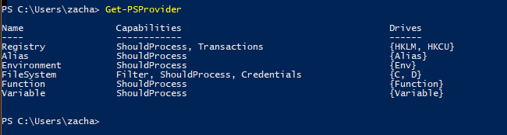
  + Capabilities of Providers:
    - ShouldProcess—provider supports the use of the -WhatIf and -Confirm parameters, enabling you to test certain actions before committing to them.
    - Filter—provider supports the -filter parameter on the cmdlets that manipulate providers’ conten.
    - Credentials—provider permits you to specify alternate credentials when connecting to data stores.
    - Transactions—provider supports the use of transactions which allows you to use the provider to make several changes, and then either roll back or commit those changes as a single unit.
* PSDrive 🡪 uses a single provider to connect to data storage.  
  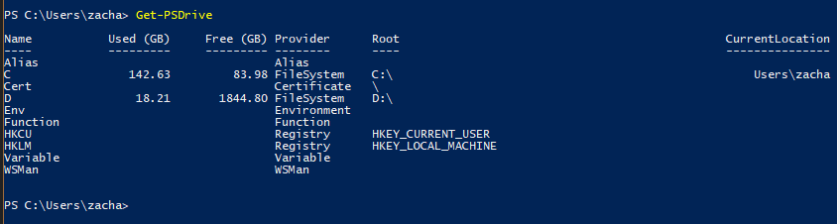
* 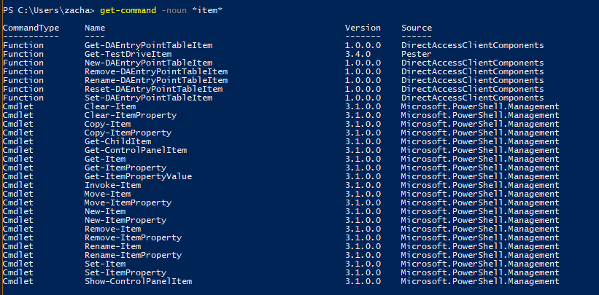
* 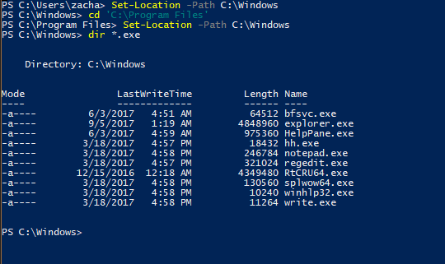
* Accessing the registry  
  
* Working in the registry in PS:  
  